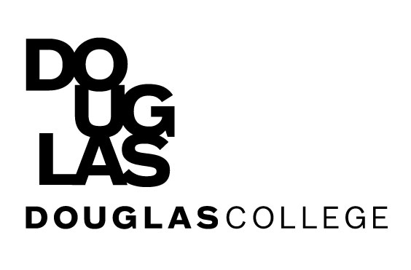
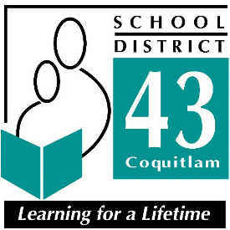
Education Assistant
Open House

Monday, April 30th, 2018, 6:30pm – 8:00pm
Gallery Room 1100 Winslow Avenue, Coquitlam

Come and learn about job opportunities in SD43 and programs being offered through Douglas College. Meet with Recruiters and Staff from SD43 and Douglas College – Classroom and Community Support Program.
We will be accepting resumes at this event!

Refreshments will be served

